DNSMAP TOOL – COMPREHENSIVE TECHNICAL DOCUMENTATION
A Fast Subdomain Enumeration Tool for Ethical Hacking & Penetration Testing

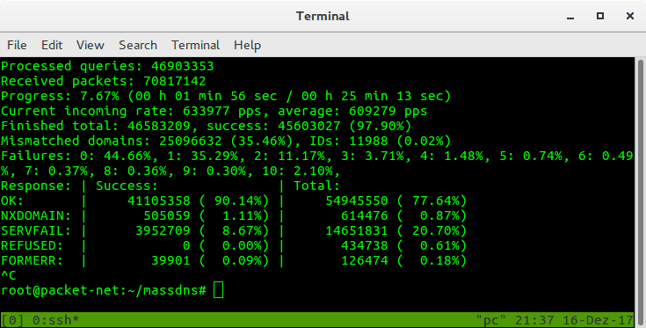
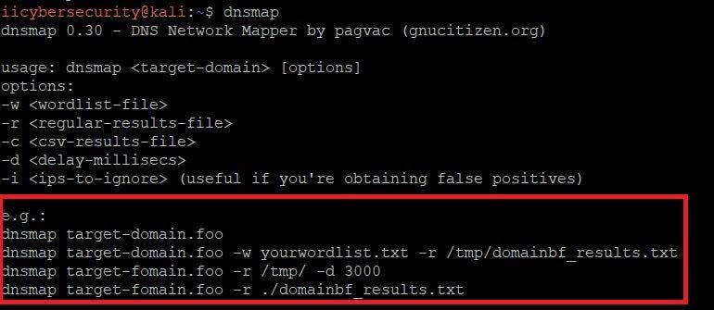

ABSTRACT
Subdomain enumeration plays a crucial role in expanding the attack surface during penetration testing engagements. Many organizations expose multiple subdomains for development, testing, administration, and cloud services without adequate security controls. This document presents an in-depth technical study of DNSMAP, a lightweight and high-speed DNS enumeration tool specifically designed for subdomain discovery through brute-force techniques. The report explains the theoretical background, internal working methodology, command usage, practical case study, advantages, limitations, and defensive considerations. The purpose of this documentation is to provide a clear academic and practical understanding of DNSMAP suitable for cybersecurity coursework and professional learning.

1. INTRODUCTION
In modern enterprise environments, organizations rarely operate using a single domain or server. Instead, they rely on multiple subdomains to separate services such as email, development, cloud infrastructure, and internal portals. These subdomains often become weak points in an organization’s security posture due to misconfigurations, outdated software, or lack of monitoring.
Subdomain enumeration is the process of identifying these hidden or less-visible domain components. Attackers frequently use this technique to locate vulnerable services before launching targeted attacks. Ethical hackers and penetration testers perform subdomain enumeration to evaluate how much information an attacker can gather without authentication.
DNSMAP is a specialized tool created to perform fast and efficient subdomain enumeration using brute-force techniques. This document explores DNSMAP in detail and explains its role in penetration testing.

2. OBJECTIVE OF THE STUDY
The objectives of this documentation are:
- To understand the importance of subdomain enumeration
- To study the working mechanism of DNSMAP
- To analyze DNSMAP command usage and features
- To demonstrate real-world usage through a case study
- To identify strengths, limitations, and security implications
- To present exam-ready and submission-ready content

3. BACKGROUND: SUBDOMAIN ENUMERATION IN CYBER SECURITY
Subdomain enumeration is a subset of DNS reconnaissance and falls under the Information Gathering (Reconnaissance) phase of penetration testing. Unlike exploitation, this phase focuses on discovering assets rather than attacking them.
Subdomains may reveal:
- Development and testing servers
- Administrative dashboards
- Legacy applications
- Cloud-hosted services
- VPN and authentication portals
Many of these systems are not indexed by search engines and are often forgotten by administrators, making them attractive targets for attackers.
DNSMAP focuses specifically on uncovering such subdomains using brute-force DNS resolution.

4. OVERVIEW OF DNSMAP TOOL
DNSMAP is an open-source DNS enumeration tool developed to perform fast subdomain discovery. It uses a wordlist-based brute-force approach to test common subdomain names against a target domain.
DNSMAP is written in C, making it extremely lightweight and faster than many scripting-based enumeration tools. It is commonly used during the early stages of penetration testing to quickly identify reachable subdomains.
DNSMAP does not perform exploitation or vulnerability scanning. Its sole purpose is to identify valid subdomains and their corresponding IP addresses.

5. ARCHITECTURE AND WORKING MECHANISM
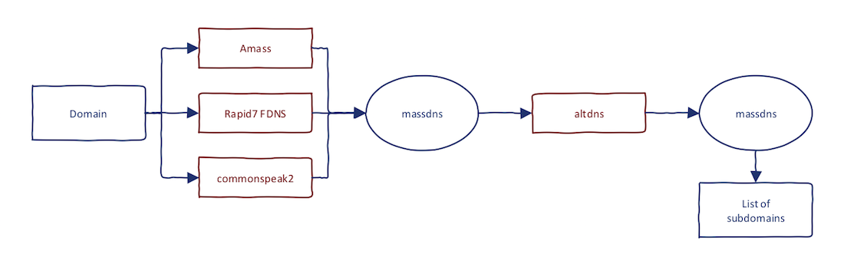

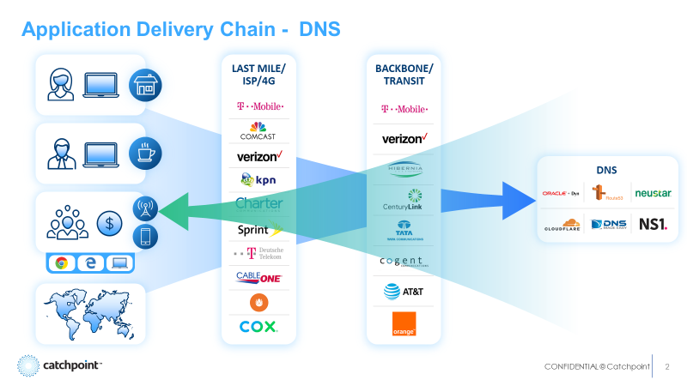
DNSMAP follows a simple yet efficient working mechanism:
- Wordlist Loading
DNSMAP loads a predefined or custom wordlist containing potential subdomain names.
- DNS Query Generation
Each word from the list is appended to the target domain.
- DNS Resolution
DNSMAP sends DNS queries to resolve each generated subdomain.
- Response Validation
Valid DNS responses are recorded, while unresolved entries are discarded.
- Result Display
The tool outputs discovered subdomains along with their IP addresses.
This direct brute-force approach enables DNSMAP to operate at high speed with minimal resource consumption.

6. INSTALLATION AND ENVIRONMENT
DNSMAP is pre-installed in Kali Linux and is available in most penetration testing distributions.
To verify installation:
dnsmap
DNSMAP runs efficiently on low-resource systems, making it suitable for lab environments and academic usage.

7. COMMAND USAGE AND ANALYSIS
7.1 Basic Subdomain Enumeration
dnsmap example.com
This command performs brute-force subdomain enumeration using the default wordlist.

7.2 Quiet Mode
dnsmap example.com -q
Suppresses banner output, useful for scripting and clean logs.

7.3 Delay Between Requests
dnsmap example.com -d 300
Introduces a delay between DNS queries to avoid detection or rate limiting.

7.4 Using a Custom Wordlist
dnsmap example.com -w custom_wordlist.txt
Used when targeting organizations with predictable naming conventions.

7.5 Output Redirection
dnsmap example.com > dnsmap_results.txt
Stores results for reporting or further analysis.

8. PRACTICAL CASE STUDY
Scenario
A penetration test is conducted against a fictional organization named example-corp.com.
Execution
dnsmap example-corp.com
Observations
- dev.example-corp.com resolved to an internal IP
- mail.example-corp.com exposed email infrastructure
- vpn.example-corp.com revealed a remote access portal
Impact Analysis
The identified subdomains expanded the attack surface and allowed testers to prioritize further scanning and exploitation.

9. ADVANTAGES OF DNSMAP
- Extremely fast execution
- Lightweight and low resource usage
- Easy to use and beginner-friendly
- Effective for quick reconnaissance
- Suitable for academic and professional environments

10. LIMITATIONS OF DNSMAP
- Limited to brute-force enumeration
- Dependent entirely on wordlists
- No DNS record diversity (A, MX, TXT, etc.)
- Less effective against large enterprises without custom wordlists

11. DNSMAP VS OTHER ENUMERATION TOOLS
Tool | Primary Function | Strength
DNSMAP | Subdomain brute force | Speed
DNSENUM | Full DNS enumeration | Depth
DNSRECON | Modular DNS analysis | Flexibility
AMASS | Enterprise reconnaissance | Scale
DNSMAP is best suited for quick and focused subdomain discovery.

12. SECURITY AND DEFENSIVE CONSIDERATIONS
Organizations can reduce DNSMAP exposure by:
- Limiting unnecessary public subdomains
- Using wildcard DNS carefully
- Monitoring DNS query rates
- Applying proper access controls to exposed services

13. LEGAL AND ETHICAL CONSIDERATIONS
DNSMAP must only be used on systems for which explicit authorization has been obtained. Unauthorized subdomain enumeration may violate cyber laws and organizational policies.

14. CONCLUSION
DNSMAP is a powerful yet simple DNS reconnaissance tool that demonstrates how easily an organization’s digital footprint can be mapped through subdomain enumeration. While it does not perform complex analysis, its speed and efficiency make it an essential tool during the early stages of penetration testing. Understanding DNSMAP equips ethical hackers with the ability to rapidly identify exposed assets and evaluate potential attack paths.

15. REFERENCES
- Kali Linux Official Documentation
- OWASP Information Gathering Guidelines
- DNS RFC Standards

